New Items available from the Furniture Shop Jan 2020.

All items can be painted or left for you to paint at home. The list of current paint stock is at the end of this brochure.

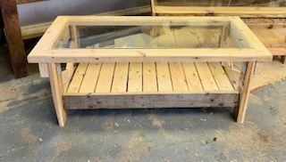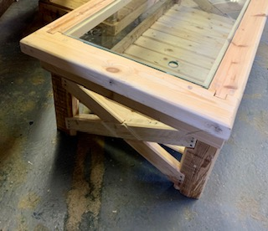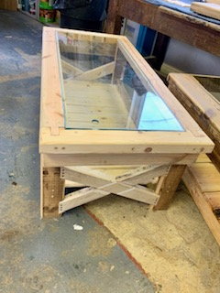
Stunning Coffee Table – untreated.
£40
Quantity - 1

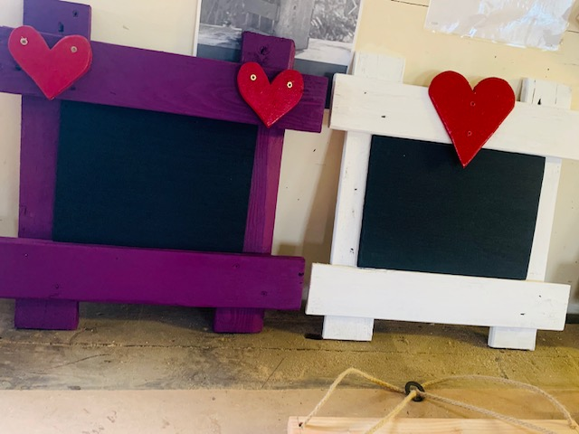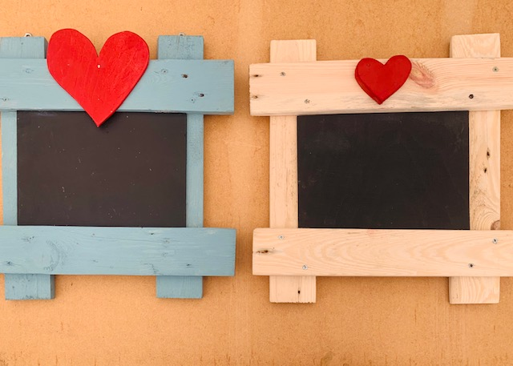

Chalkboards – with/without hearts £7
Quantity – 5 in stock but can be made to order
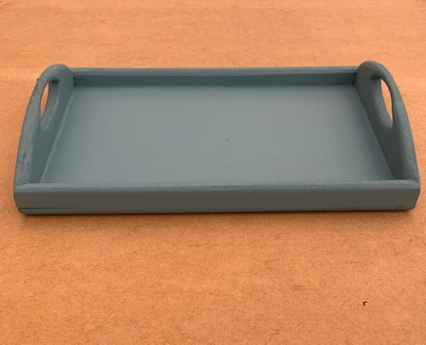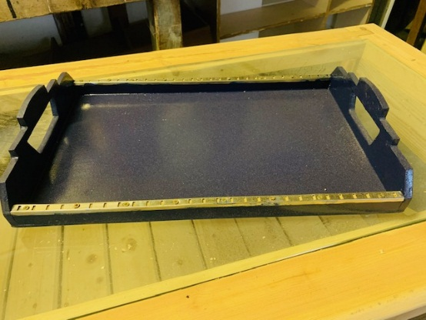

Trays – 1x Duck Egg Blue matt 1x Oxford Blue Gloss £5 –enough for 2 coffee cups and biscuits
Quantity – 2 in stock as above – can be made to order
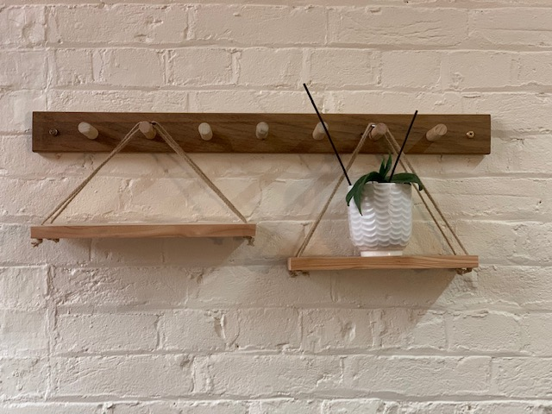
Quantity – 2 in stock as above – can be made to order
Hanging shelves – base can be painted in available colours (see below), hanging string can be longer lengths if required. £8

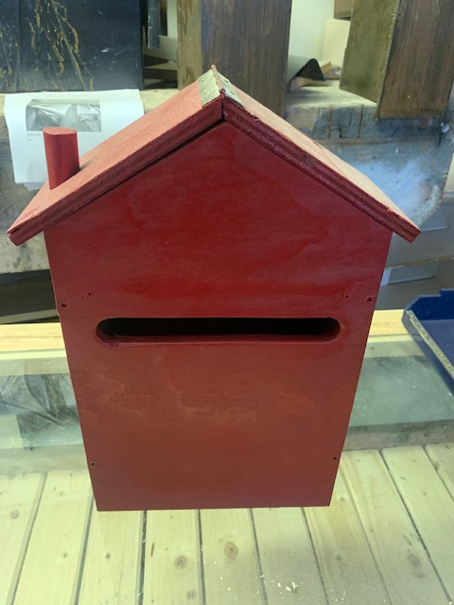

Slim Letter Box - £10 – painted Pillar Box Red
Quantity – 1 in stock – can be made to order
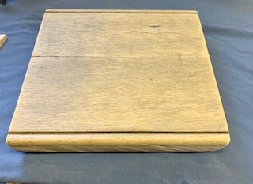

Cheese or Chopping Board - this is really heavy piece and would make a lovely part of a cheese and wine present Hamper for someone.
£15
Quantity – 1 in stock as above – can be made to order subject to stock wood
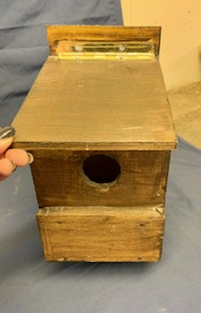
Bird Boxes – treated £5/untreated £4
To order please contact Lisa Daley on lisa.daley@justice.gov.uk or the LBA Team 01296 445055
Multiple in stock

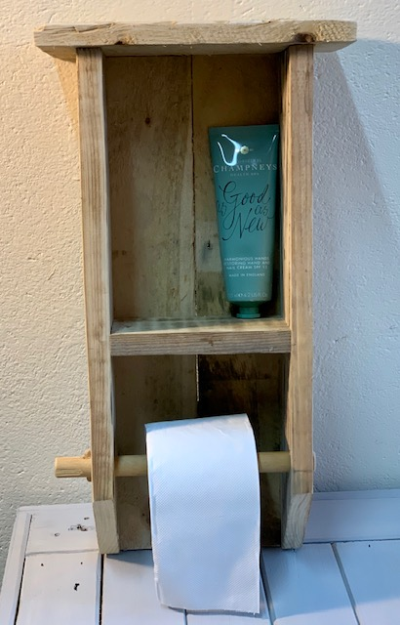
Rustic Toilet Roll Holder £10
Quantity – 1 in stock as above – can be made to order
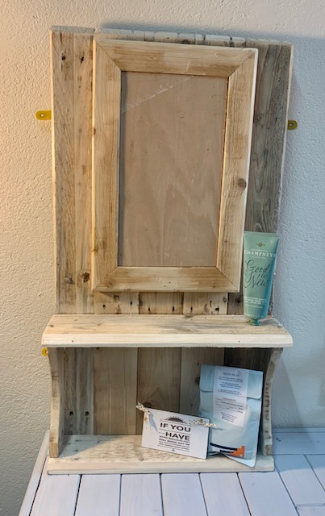 Display Unit £15
(please note this has been painted with blackboard paint in the centre section)
Quantity – 1 in stock as above – can be made to order
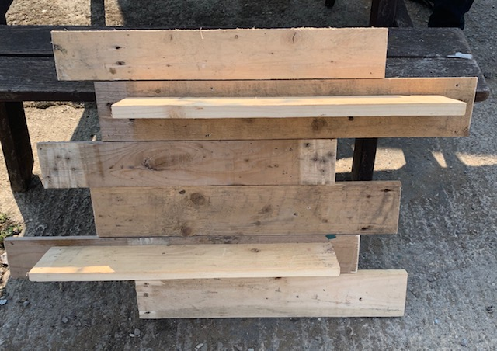

There are various designs/sizes of these shelving units and some painted and some unpainted.
£10 – unpainted
£12 - painted
Multiple in stock.

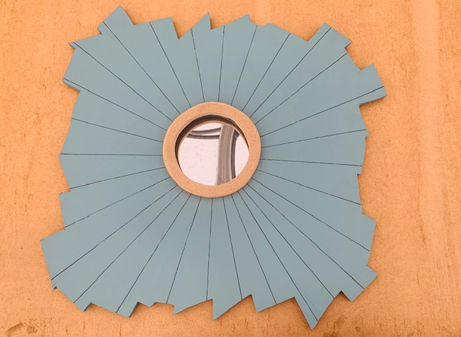
Quantity – 2 in stock as above – can be made to order

Large Mirrors £8 each
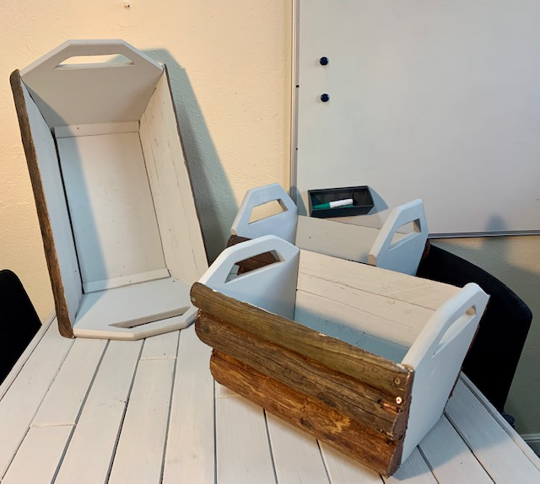
Wooden Baskets – good for log storage or other items.
Small - £6 Large £8
Made to Order only

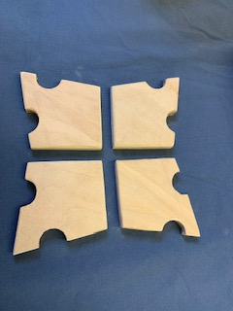
Coaster Set – various designs £3
Mulitple in stock

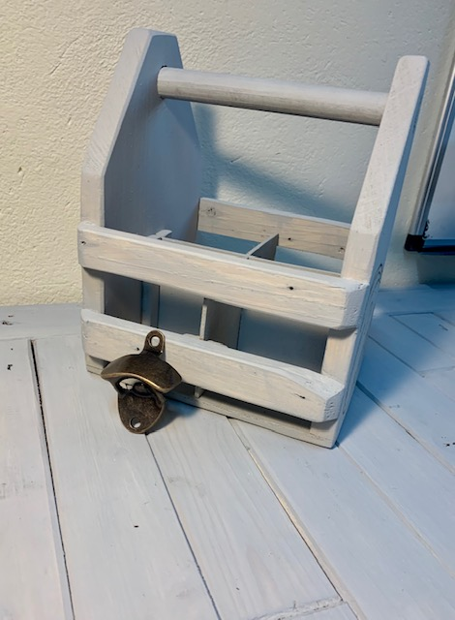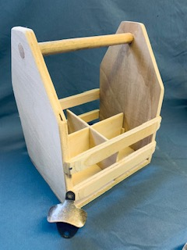

Bottle Holder – with bottle opener for self-attachment £10 or without opener £8
(painted or unpainted or unpainted on request)
Quantity – 2 in stock as above – can be made to order

To order please email lisa.daley@justice.gov.uk or phone the LBA team on 01296 445055

Current Paint Stock available:
- Plum Berry (Matt)
- Dark Duck Egg (Matt)
- Deep Red (Gloss)
- Oxford Blue (Gloss)
- Signal Red (Gloss)
- Dove Grey Chalk Paint
- Country Brown wood paint
- Woodland Green wood paint
- Gold Wax finish
- Silver Wax finish

